what’s going on in…
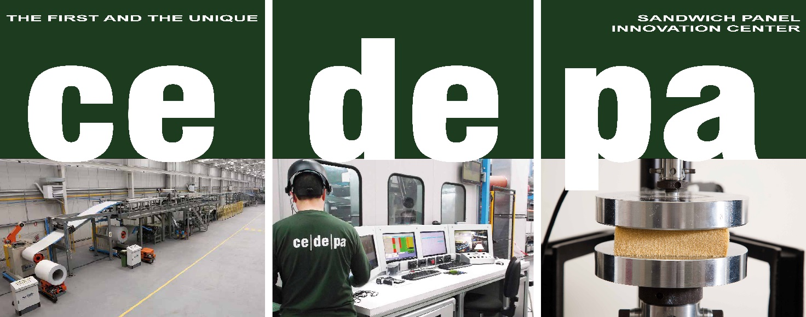

The role of CEDEPA in supporting customers facing challenges in the construction industry

It will be discussed within Dow Polyurethanes’ virtual customer event
“Shaping the future with Polyurethanes”
2021 March 22-23

Now more than ever, collaborations among Key Players, Trade Associations and Technology Experts are strategic to support customers that want to overcome challenges and stay competitive in the construction market.

CEDEPA is a unique platform for the industry, valuable both for newcomers, as they can avail of an industrial-scale line and qualified consultancy, and market leaders, as they can count on an innovation partner which provides tools for testing, prototyping and validating new technologies.

The role of CEDEPA, its mission and capabilities will be discussed within Dow Polyurethanes’ virtual customer event, “Shaping the future with Polyurethanes”, in a special session dedicated to panels, “Unlocking Opportunities with Next-Gen Insulation Metal Panels”, where Luca Ceresa – Saip Commercial Director - will illustrate what customers can expect from CEDEPA.
Shaping the Future with Polyurethanes is a two-half-day virtual event hosted by Dow Polyurethanes (PU) demonstrating that polyurethanes have a critical role to play in developing solutions for future challenges. The event explores how Dow, customers and business partners can together shape the future with polyurethanes.

Ute Spring – R&D Director for Europe, Middle East, Africa and India - Dow Polyurethanes said, “The collaboration between Dow and Saip within CEDEPA is a game-changer for Dow`s innovation strategy in the insulated metal panels market.”

Luca Ceresa – Saip Commercial Director – said, “When I think of CEDEPA, the expression “being pioneers” seems to be very fitting for the Dow and SAIP project. We were the first to offer insulation/construction industry players a means for an effective turning point.”.

TEST AND DEVELOP INNOVATION @
ce|de|pa
www.cedepa.org

